Ministry of Higher Education and Scientific Research
University of Diyala
College of Veterinary Medicine
Gastro protective effects of aqueous -methanol extract of
Cordia dichotoma against experimentally induced
gastric ulcer in rabbits

A research submitted to council of College of Veterinary Medicine
as part of fulfillment to obtain the Bachelor’s Degree
in Veterinary Medicine and Surgery

By Sura Hilal Abdul Khaliq

Under supervision of

Professor Dr. AL-Khafaji Nazar Jabbar Muslih

2017

بِسْمِ اللهِ الرَّحْمنِ الرَّحِيمِ

}وَيَسْأَلُونَكَ عَنِ الرُّوحِ قُلِ الرُّوحُ مِنْ أَمْرِ رَبِّي وَمَا أُوتِيتُم مِّن الْعِلْمِ إِلاَّ قَلِيلاً{

(صدق الله العظيم)
سورة الإسراء الآية 85

الإهداء
إلى من ركع العطاء أمام قدميها وأعطتنا من دمها وروحها وعمرها حبا وتصحيحا ودفعا لغد أجمل إلى الغالية التي لا نرى الأمل إلا من عينها أمي الحبيبة.
إلى من كلله الله بالهيبة والوقار، إلى من علمني العطاء بدون انتظار ،إلى من احمل اسمه بكل افتخار. ارجوا من الله ان يمد في عمرك لترى ثمارا قد حان قطافها بعد طول انتظار وستبقى علامتك نجوم اهتدي بها اليوم وغدا والى الأبد...والدي العزيز
الى الروح التي سكنت روحي عائلتي الكريمة

-A-

شكر وثناء
إلى الذي لا تفيه الكلمات والشكر ، إلى من وقف على المنابر وأعطى من حصيلة فكره لينير دربنا إلى والدي وقدوتي التي بها اهتدي الأستاذ الدكتور نزار جبار مصلح الخفاجي.
شكري وتقديري إلى كل من ساعدني في إنجاز هذا العمل.. الدكتوررعد محمود والدكتور احمد حنش

-B-

Abstract
Ulcer is a common gastrointestinal disorder which is seen among many people. It is basically an inflamed break in the skin or the mucous membranes lining the alimentary tract. Ulcerations occur when there is a disturbance of the normal equilibrium caused by either enhanced aggregation or diminished mucosal resistance. It may be due to the regular usage of drugs, irregular food habits, stress, and so forth. 12 male rabbits weighing 1-1.900 kg were used after acclimatization for a period of 2 weeks to animal house conditions and had free access to food and water. Basal diet was alfalfa and concentrated food. Rabbits were fasted for 24 h prior to the experiment but allowed free access to water except for the last hour before the experiment. The animals were randomly classified into 3 groups (4 rabbits each). Rabbits of 1st group non- treated with plant extract, nor exposed to aspirin, as control group. Those of 2nd group not treated with plant extract, but exposed to aspirin at a dose rate of 300 mg / kg b. wt. mixed with 2 ml water orally, while those of 3rd group were pretreated with aqueous – methanol (30:70%) extract of Cordia dichotoma for 9 day at a dose rate of 300 mg / kg. b. wt. orally before aspirin administration at a dose rate of 300 mg / kg in 2 ml water orally. The animals were killed with an ether overdose three hour after aspirin administration. Immediately after the animals were sacrificed, their stomachs were dissected out, cut along the greater curvature and the mucosa was rinsed with cold normal saline to remove blood contaminate, if any. The surface area of each lesion was counted and scored. The ulcer index for each rabbit was taken as the mean ulcer score. The percentage of ulcer protection (%UP) was calculated. Aqueous – methanol extract of Cordia dichotoma fruit showed mild gastric protection against aspirin induced ulcer.

C - -
List of contents
Series | Title | Page
1 | Dedication | A
2 | Acknowledgement | B
3 | Abstract | C
4 | List of content | D
6 | List of Tables | E
5 | List of Picture and photo | F
7 | Introduction | 1
8 | Literature review | 3
9 | Material and Methods | 6
10 | Results | 10
11 | Discussion | 21
12 | Conclusion and recommendation | 24
13 | References | 25
14 | Abstract in Arabic | أ

-D-
List of Tables
Series | Title | Page
1 | Table- 1- Showing Body weight, Body temperature, Respiratory rate, Heart rate of rabbits in experiment | 10
2 | Table-2- showing Bleeding time, Clotting time of rabbits in experiment | 10
3 | Table-3- Showing total erythrocyte count, Hb concentration, PCV%, erythrocyte indices (MCV, MCH, MCHC) of rabbits in experiment | 11
4 | Table-4- Showing total leucocytes count, differential leucocyte count (Heterophil%, Lymphocyte%, Eosinophil%, Basophil% and Monocyte%) of rabbits in experiment | 12
5 | Table-5- Showing RBS, ALT, AST, TSB., TSP of rabbits in experiment | 13
6 | Table-6- Showing volume, PH, Free acidity, Total acidity of gastric juice, No. of lesion, and % protection of rabbits in experiment | 14

-E-
List of pictures and photo
Series | Items | Page
1 | Picture -1- showing method of measuring PH of stomach content by PH meter | 15
2 | Picture 2, 3 showing stomach mucosa of rabbits exposed to aspirin without treatment with plant extract | 16
3 | Picture-4- showing stomach mucosa of rabbits exposed to aspirin after treatment with plant extract | 17
4 | Slide -1- showing histological changes in stomach mucosa of rabbit exposed to aspirin and treated with plant extract | 18
5 | Slide-2- showing histological changes in gastric mucosa of rabbit exposed to aspirin with out treatment with plant extract | 19
6 | Slide -3- showing histological changes in gastric mucosa of rabbit not exposed to aspirin , nor treated with plant extract | 20

-F-
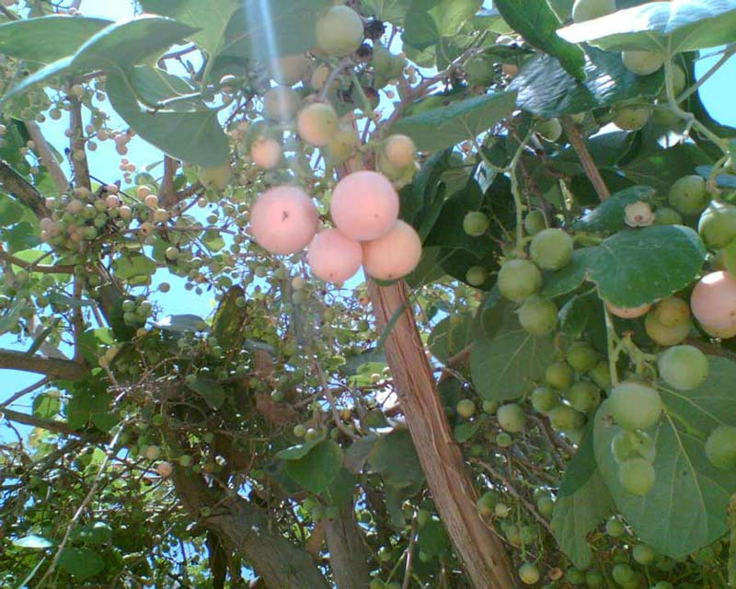
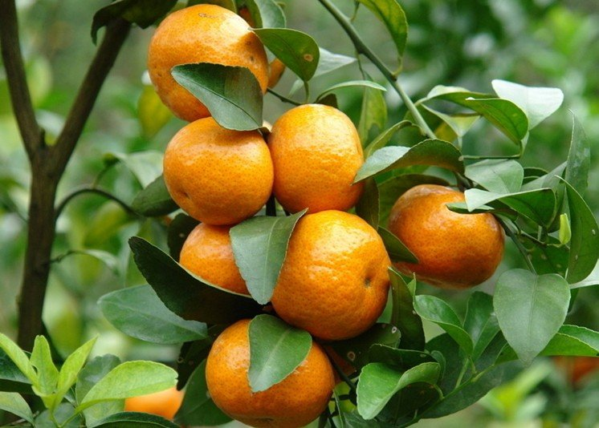
Cordia
-G-

